Brothers Grimm

Name of the Student
Professor
Course
Date

Brothers Grimm
Jacob Ludwig Carl Grimm and Wilhelm Carl Grimm were respectively born in the year 1785 and 1786 in the Holy Roman Empire with is now Germany.
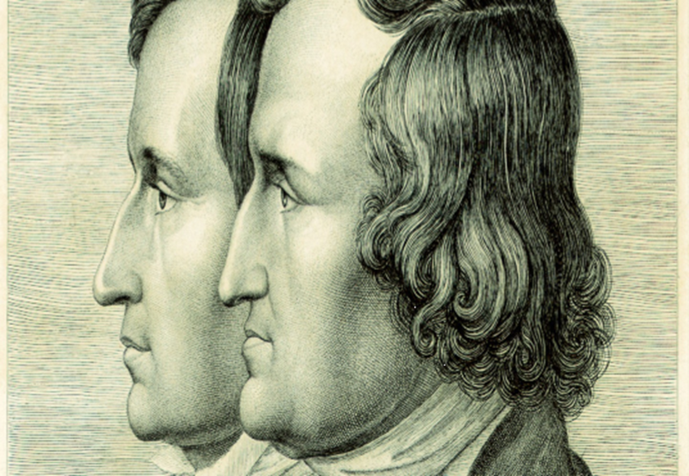
They were born in a family of nine children, three of whom died at an early age. Jacob Grimm was the second eldest while Wilhelm was the third eldest in the family. It happened that their father died in the year 1796. The demise impoverished the family, including the Grimm brothers, for many years. Despite the difficulties, the Grimm brothers manage to attend the University of Marburg, Germany. It is at Marburg where they were awakened in literature and poetry by works of Clemens Brentano, who was a German novelist, poet, and a major representative of German Romanticism. Also, while at Marburg, they were taught antiquarian investigation by Friedrich Karl von Savigny, who was a German historian and Jurist. It is these experiences and exposures that marked their lifelong dedication to researching the history and nature of German folktales, literature, and language. Their works were so profound that it formed the basis of German folklore studies. It is worth mentioning that in their time they were the most important German scholars (Papa & Bashota, 2018).
In the time when the Grimm Brothers were growing up, this is in the 18th century, Europe was undergoing through a period of intense academic productivity. People placed a lot of emphasis on philosophy, mathematics, and science. They drew inspirations from legacies of ancient Greece, Rome, India, and China. There was a belief that it is only by use of intelligence that the world problems can be solved. The Grimm brothers were engulfed in this wave, thus they collected and researched Folklores with an aim to try to solve some of the world problems. The tuff experience of growing up without a father, who was the family provider, influenced them to collect folklores that narrated about the difficulties that most Germans were experiencing. The collected folklores from both peasants and the middle class. Then they would edit the works in order to fit the intellectual threshold. In literature, one of the major contributions in world history is that they came up with Grimm’s Law. This was an identification that certain Indo-European consonants go through regular changes in Germanic languages, a thing that is not experienced in languages such as Latin and Greek. The importance of Grimm Law is that it demonstrates the development of languages such as English and Dutch from the old Germanic languages. Also, it demonstrates language change in the sense of new groups of language instead of word changes (Wilcox, 2020).
The Grimm brothers were part of the Romanticism. This is because, in their time, that is the 1800s, German Romanticism was being used for the progress of national linguistic communications, folklore, and local traditions. There was a deficiency of history, thus Brothers Grimm responded to the deficiency by collecting and uniting Germany fairy tales. They embraced the impressions of Romanticism at a way to connect with Germans emotionally. Romanticism emphasized on inspiration, primacy, and subjectivity of an individual. Romanticism works focused on a person’s inner emotions and inner world. Nature was viewed as a teacher and it had a profound interest in history. More so, Romanticism valued simple life, folk traditions that had a one-sided opinion (Furst, 2017). These are Brother Grimm's works that have contributed to the history of history.
Hansel and Gretel
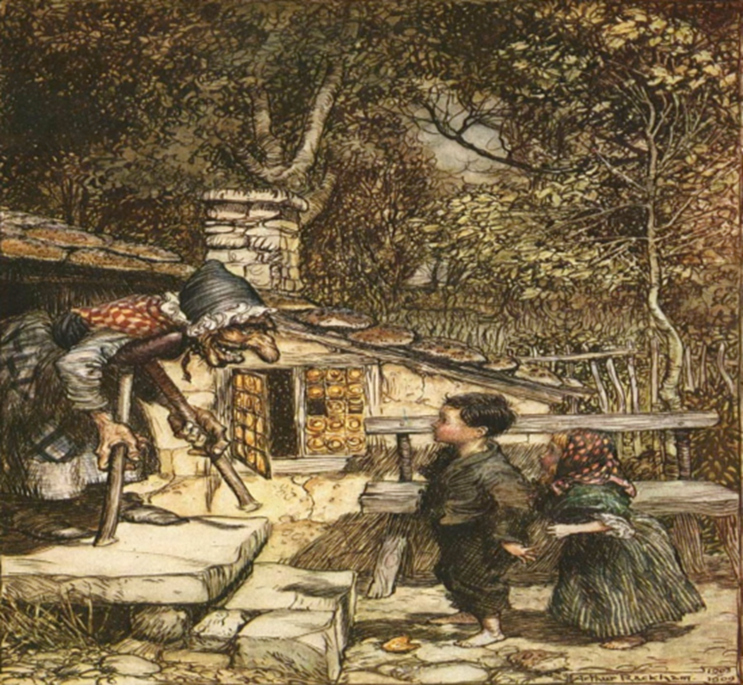
Source: Grimm, 2020.
Hansel and Gretel are of the Grimm’s Fairy Tales. It was published in the year 1812. The fairy tale tells of young children who are left in the forest and encounter a cannibalistic witch. This witch lives in a house that is made of gingerbread, cakes, sweets, and other lots of treats. The witch plan is to fatten the children and then kill them but the young girl manages to defeat the witch. This fairy tale qualifies to fall under romanticism because of the fact that it uses simple and common objects to tell a story of kids with grit. These kids are clever and resourceful. The message is that people or kids who are clever and resourceful can save themselves against tough situations. Brothers Grimm used education to overcome difficulties after their father died.
Little Red Riding Hood
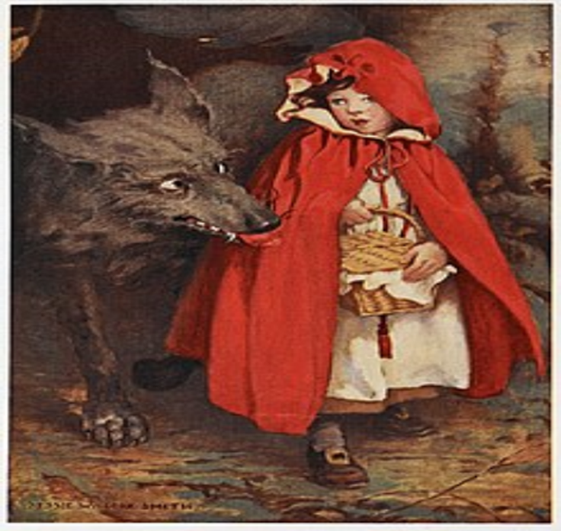
Source: Grimm, 2016
This is a fairy tale about a young girl and a big wolf. The girl goes through the woods to provide foodstuff to her sick grandmother. But the wolf traces up to her grandmother’s house. The wolf eats the grandmother and then covers herself up so as to pretend to be the grandmother. When the girl comes to deliver food, the wolf eats her too. Luckily, a woodcutter comes and cuts open the wolf. Thus, the grandmother and the girls are saved. This fairy tale intention was to raise awareness of young girls, they should not trust strangers as the young girl did by revealing to wolf her business. The fairy tale is inspired by nature and it is meant to affect the inner emotions of a person.
In conclusion, it is no doubt that Brothers Grimm had a profound contribution to the world of literature. Their magnificent works are attributed to forming the civilization of German folklore. Their career was shaped up by their early upbringing and university exposure.

Reference
Papa, R., & Bashota, H. (2018). Translation aspects of brothers Grimm Fairy Tales and comparison to translation between English and Albanian version.
Furst, L. R. (2017). Romanticism (Vol. 2). Taylor & Francis.
Grimm, B. (2020). Hansel and Gretel. Strelbytskyy Multimedia Publishing.
Grimm, B. (2016). Little Red Riding Hood. BoD–Books on Demand.
Wilcox, B. E. (2020). Brothers Grimm: From the Oral to the Literary and Beyond. A Companion to World Literature, 1-12.

